**Python Programming Assignment 02**

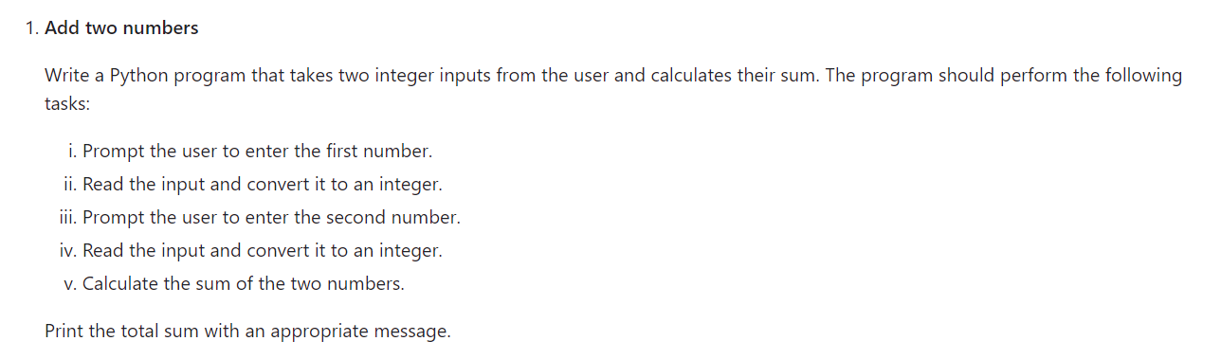

# Add two numbers

# Prompt the user to enter the first number

first_number = int(input("Enter the first number: "))

# Prompt the user to enter the second number

second_number = int(input("Enter the second number: "))

# Calculate the sum of the two numbers

total_sum = first_number + second_number

# Print the total sum

print(f"The sum of {first_number} and {second_number} is {total_sum}.")

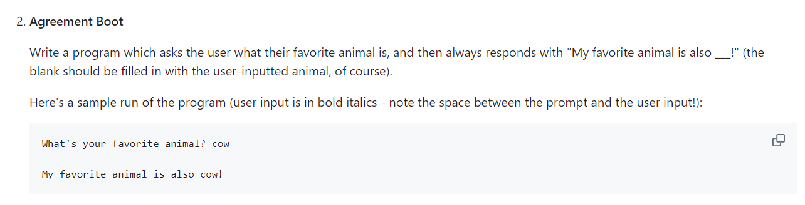

# Agreement Boot

# Prompt the user to enter their favorite animal

favorite_animal = input("What's your favorite animal? ")

# Respond with a message that includes the user's favorite animal

print(f"My favorite animal is also {favorite_animal}!")

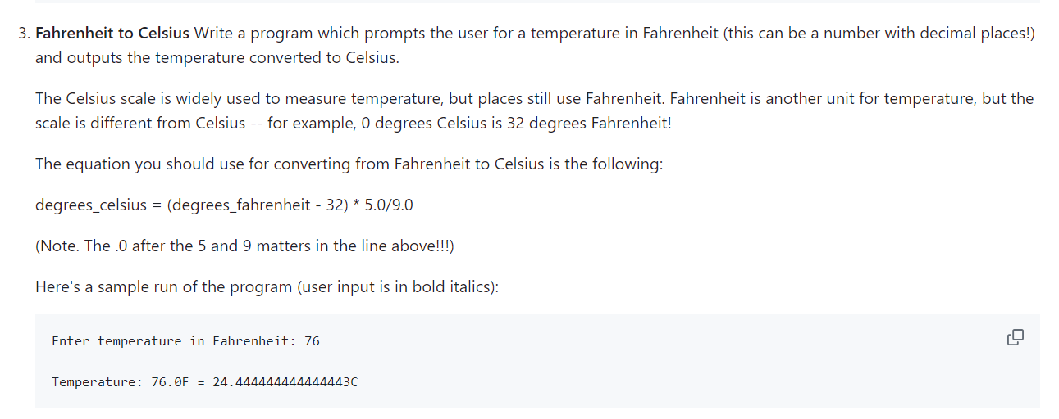

# Fahrenheit to Celsius

# Prompt the user to enter a temperature in Fahrenheit

fahrenheit = float(input("Enter temperature in Fahrenheit: "))

# Convert the temperature to Celsius using the formula

celsius = (fahrenheit - 32) * 5.0 / 9.0

# Print the result

print(f"Temperature: {fahrenheit}F = {celsius}C")

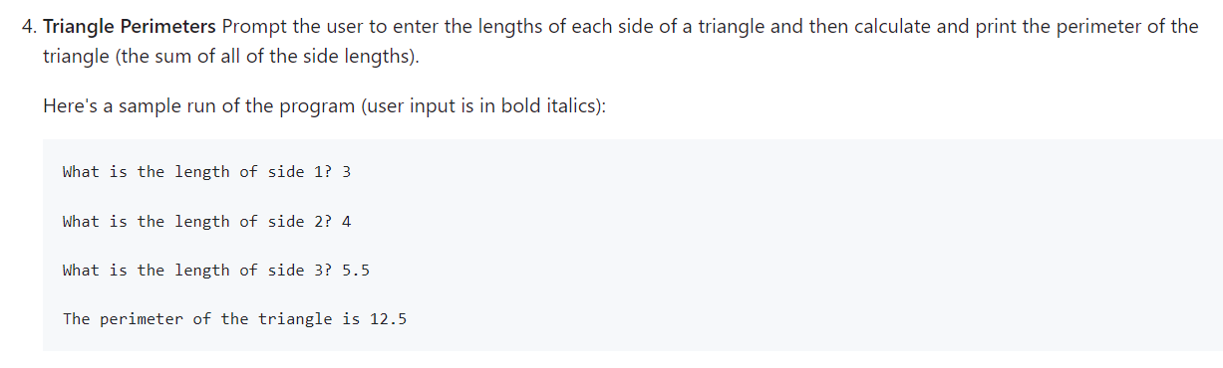

# Triangle Perimeters

# Prompt the user to enter the length of side 1

side1 = float(input("What is the length of side 1? "))

# Prompt the user to enter the length of side 2

side2 = float(input("What is the length of side 2? "))

# Prompt the user to enter the length of side 3

side3 = float(input("What is the length of side 3? "))

# Calculate the perimeter of the triangle

perimeter = side1 + side2 + side3

# Print the perimeter with an appropriate message

print(f"The perimeter of the triangle is {perimeter}")

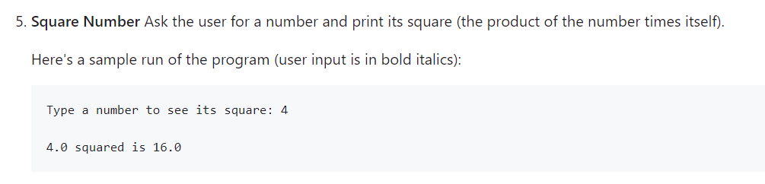

# Square Number

# Prompt the user to enter a number

number = float(input("Type a number to see its square: "))

# Calculate the square of the number

square = number * number

# Print the result

print(f"{number} squared is {square}")



# Delete a number

# Define the list

numbers = [1, 2, 3, 4, 5]

# Remove the number 3 from the list

numbers.remove(3)

# Print the updated list

print(numbers)

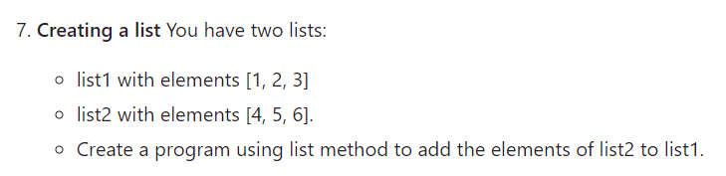

# Creating a list

# Define the lists

list1 = [1, 2, 3]

list2 = [4, 5, 6]

# Add the elements of list2 to list1

list1.extend(list2)

# Print the updated list1

print(list1)



# Pop method

# Define the list

items = [10, 20, 30, 40]

# Use the pop method without any arguments

removed_item = items.pop()

# Print the updated list and the removed item

print(items)

print(removed_item)



# Index Method

# Define the list

colors = ['red', 'blue', 'green', 'yellow']

# Find the index of 'green'

index_of_green = colors.index('green')

# Print the index

print(index_of_green)



# Get last element

def get_last_element(lst):

    # Print the last element in the list

    print(lst[-1])

# Example usage

example_list = [10, 20, 30, 40]

get_last_element(example_list)  # Output will be 40

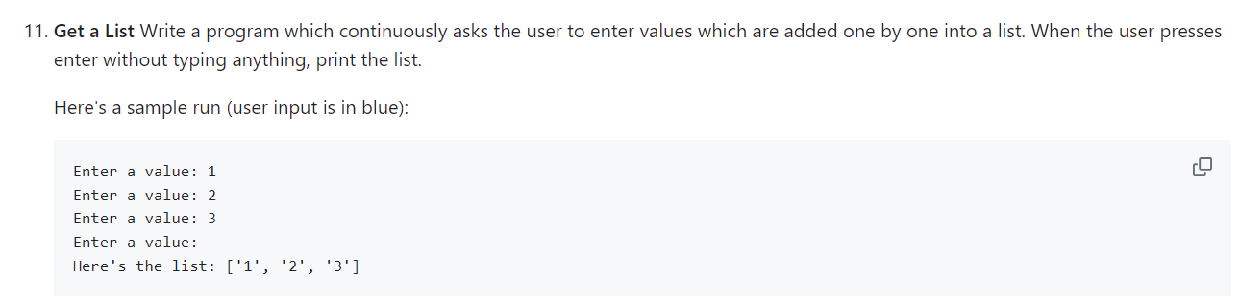

# Get a List

def collect_values():

    values = []  # Initialize an empty list

    while True:

        # Prompt the user to enter a value

        value = input("Enter a value: ")

        # Check if the input is empty

        if value == "":

            break  # Exit the loop if the input is empty

        # Add the value to the list

        values.append(value)

    # Print the list after exiting the loop

    print("Here's the list:", values)

# Run the function

collect_values()